PROJECT TITLE-Intelligent Admissions: The Future Of University Decision Making with Machine Learning

NM_ID: NM2023TMID17799

**Define Problem/Problem Understanding**

# Specify the Business Problem

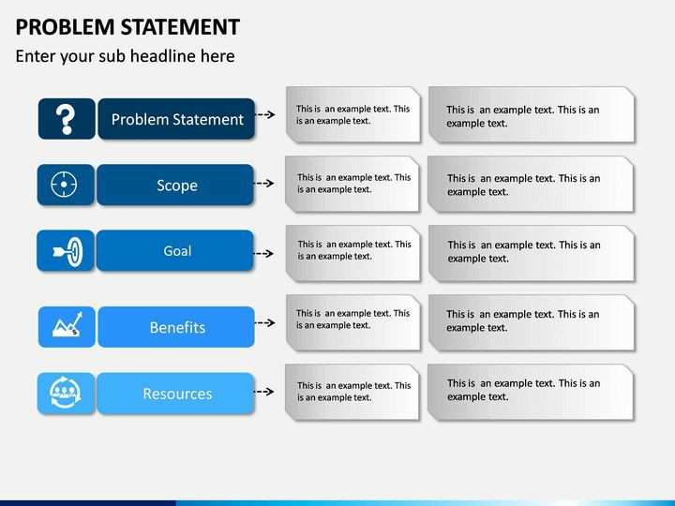

* Modern universities are under constant pressure to improve the management of their activities, because of the increasing complexity of their tasks and structure and the demands of their fund-supplying environment.
* In certain ways universities are more difficult to manage than ,say the typical business enterprises.
* They inevitably have a dualistic decision-making and management structure(academic and administrative) and meaningful planning is handicapped by the vagueness and multiplicity of their objectives.
* Even within these limitations ,however much can be done to apply proven management principles to the management of universities, and the author draws on 30 years of experience in this field to give practical examples and guidelines.



* It lets admission teams capture student inquiries, check their eligibility, follow-up,collect documents and complete the application process digitally. The admission management system also allows students to apply online, check their application status, submit documents and pay fees online.



* The main goal of the online admission system is to automate the admission process and complete it faster.
* Eventually, candidates get to know everything about the institution from the app. Thus, students can complete their entire admission process remotely using an online admission management system.



* During admission, students have to pay for forms, registration, enrollment, etc. Keeping records of all these payments manually can be challenging.
* Also, paper-based work is prone to errors and admissions. An admission management system streamlines the fee payment process while eliminating human errors and consuming less time.

# E:\1d8443212edf57038e9610faddef4e11.jpg

* The online College Admission System consists of three Modules such as User, Server, and Admin. The student who wants to seek admission is the user of the online system. The student registers himself/herself with the system and becomes authenticated user after the login process.

# 